Department of Information Technology
Faculty of Computing
The Islamia University of Bahawalpur



Software Design Document
Real-Time Face Mask Detection Using Convolutional Neural Networks and OpenCV

Submitted by
Hamid Yaseen
F22BINFT1M01095

Submitted to
Mam Sara Fareed

Summery
This project develops a real-time computer vision system capable of automatically detecting whether individuals are wearing face masks. The system uses a labeled dataset containing masked and unmasked faces to train a Convolutional Neural Network (CNN) for binary classification. The pipeline performs essential steps including image preprocessing, data augmentation, and model optimization to ensure high detection accuracy. After training, the model is integrated with an OpenCV-based face detection module that processes live video streams from a webcam. For each detected face, the system predicts mask status and overlays visual feedback using bounding boxes and classification labels. This end-to-end solution provides an efficient and practical tool for real-time monitoring in public spaces, supporting safety compliance and enabling automated surveillance applications.

Table of Content

1. Introduction 4
1.1. Purpose of SDD 4
1.2. Scope 4
2. Application Architecture 4
2.1. Architectural Overview 4
2.2. High-Level Architecture Components 5
3. System Workflow (Design Flow) 5
4. Data Model Schema 6
4.1. Dataset Structure 6
4.2. Model Data Entities 6
4.3. Model Storage 6
5. User Interface Design 7
5.1. UI Overview 7
5.2. UI Components 7
5.3. UI Characteristics 7
6. Design Diagrams 8
6.1. System Architecture Diagram (Textual Representation) 8
6.2. Data Flow Diagram (DFD - Level 1) 9
7. Non-Functional Design Considerations 9
7.1. Performance 9
7.2. Scalability 9
7.3. Reliability 10
7.4. Maintainability 10
8. Conclusion 10

- Introduction

  - Purpose of SDD
This Software Design Document (SDD) provides a detailed technical design of the Real-Time Face Mask Detection System based on the approved Software Requirements Specification (SRS). The document translates functional and non-functional requirements into a concrete system design, describing architecture, data models, user interface design, and system workflows.

  - Scope
This SDD covers :

- Application Architecture
- Data Model / Schema
- User Interface Design
- Design Diagrams and System Workflow

- Application Architecture

  - Architectural Overview
The system follows a modular layered architecture consisting of:

- Presentation Layer (User Interface)
- Processing Layer (Video & Frame Processing)
- Machine Learning Layer (YOLOv8 Model)
- Data Layer (Model files, datasets, configuration)

The architecture is designed for real-time performance, scalability and ease of maintenance.

  - High-Level Architecture Components
- Video Capture Module

  - Captures live video frames from webcam or CCTV using OpenCV.

- Frame Preprocessing Module

  - Resizes frames
  - Normalizes Pixel Values
  - Converts color spaces if required

- Face Detection & Mask Classification Module

  - Uses YOLOv8n model
  - Detects faces and classifies them as Mask or No Mask

- Annotation & Display Module

  - Draws bounding boxes
  - Displays labels and confidence scores

- User Interface Module

  - Displays live stream
  - Shows real-time detection results

- System Workflow
- User starts the application
- Webcam/CCTV stream is activated
- Frames are captured continuously
- Each frame is preprocessed
- YOLOv8 model performs face detection and classification
- Results are annotated on frames
- Output is displayed in real time
- Process repeats until user stops the system

- Data Model Schema

  - Dataset Structure

The dataset used for training follows a labeled image structure:
- Image
  - Face image
- Label
  - 0 → No Mask
  - 1 → Mask

  - Model Data Entities

Entity | Description
Image Frame | Single video frame captured from stream
Bounding Box | Coordinates of detected face
Class Label | Mask / No Mask
Confidence Score | Probability score from model

  - Model Storage

- Trained YOLOv8n model stored as .pt file.
- Configuration files stored locally.

- User Interface Design

  - UI Overview
- The system provides a simple and intuitive interface designed for users with minimal technical knowledge.

  - UI Components
- Video Display Panel
  - Shows live Video feed
- Bounding Boxes
  - Green box → Mask detected
  - Red box → No Mask detected
- Text Labels
  - Display classification result above each face
- Control Options
  - Start / Stop Video Stream
  - Exit Application

  - UI Characteristics
- Real-time Updates
- Minimal user interaction required
- Clear Visual feedback

- Design Diagrams

  - System Architecture Diagram

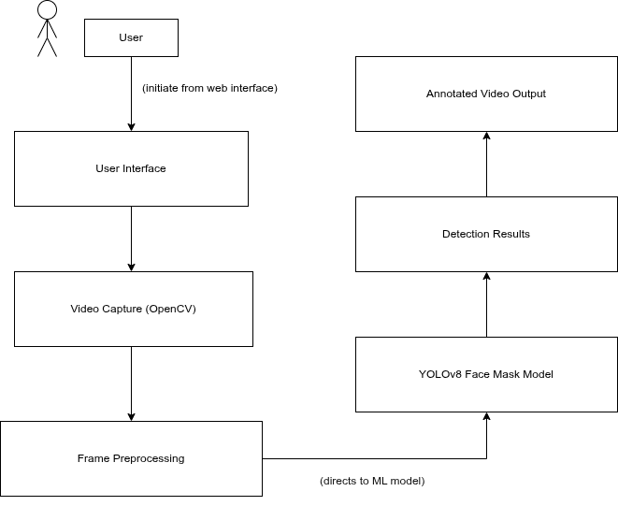

  - Data Flow Diagram

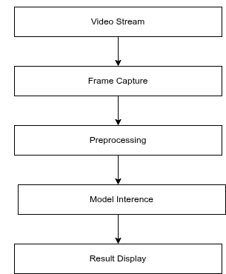

- Non-Functional Design Considerations

  - Performance
- Supports multiple faces per frame
- Extendable to multiple video streams
  - Scalability
- Supports multiple faces per frame
- Extendable to multiple video streams
  - Reliability
- Robust detection under different lighting conditions
- Stable performance during continuous operation
  - Maintainability
- Modular design
- Easy model replacement or retraining

- Conclusion
This Software Design Document provides a comprehensive technical blueprint for the Real-Time Face Mask Detection System. The design ensures alignment with the SRS, focusing on real-time performance, usability, scalability, and maintainability. The modular architecture allows future enhancements such as dashboard integration, cloud deployment, or extension to additional safety detection tasks.

